SQL queries and output:

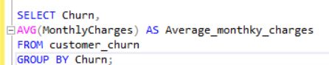

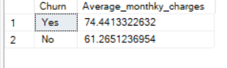

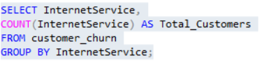

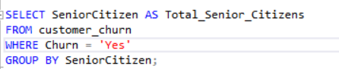

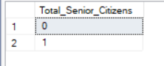

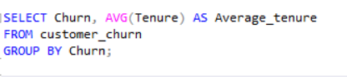

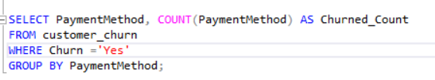

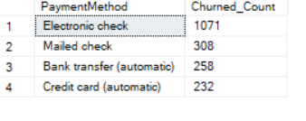

Exploratory Data Analysis:

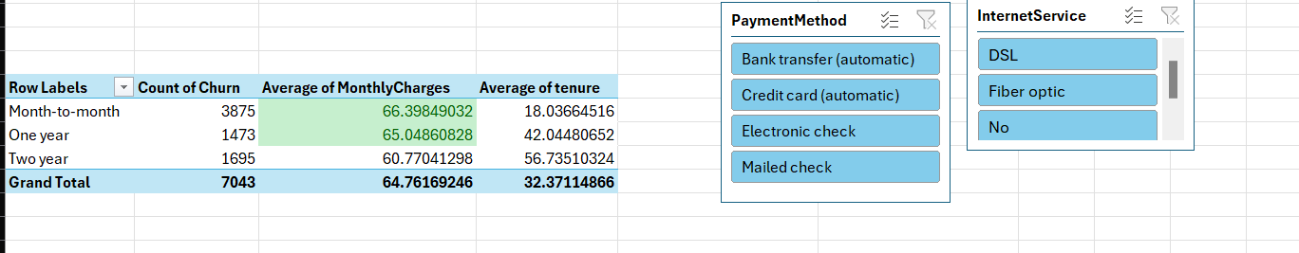

Data Visualization using Tableau:

Process Mapping:

